# Exam question 6

1. Explain adaptive modulation/coding and power principles.

This concept – adaptive link performance based on conditions in the channel

Without this tis necessary to design system with a fixed link margin and for the worst-case channel conditions – Rayleigh fading can cause a fade of 30dB which then can make the system very inefficient in terms of channel utilization.

Today systems like GSM, CDMA as well as WLAN use adaptive transmission techniques.

Adaptive modulation – change modulation relative to fading

Parameters to adapt:

* Constellation size
* Transmit power
* Instantaneous BER
* Symbol time
* Coding rate/scheme

Optimization criterion:

* Maximize throughput
* Minimize average power
* Minimize average BER

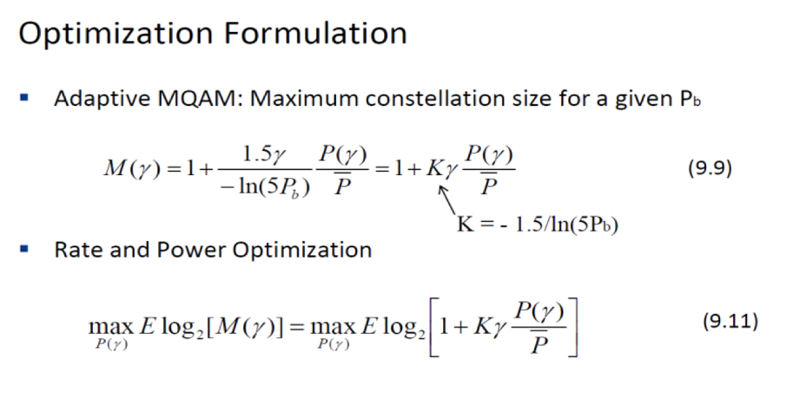

Adaptive modulation leverages fast fading to improve performance

Adaptive MQAM uses capacity-achieving power and rate adaption, with power penalty K – comes within 5-6 dB of capacity

Discretizing the constellation size results in negligible performance loss.

Constellations cannot be updated faster than 10’s to 100’s of symbol times – this is OK for most Dopplers

Estimation error/delay causes error floor